5 mins. Minimum

______ Max

Format

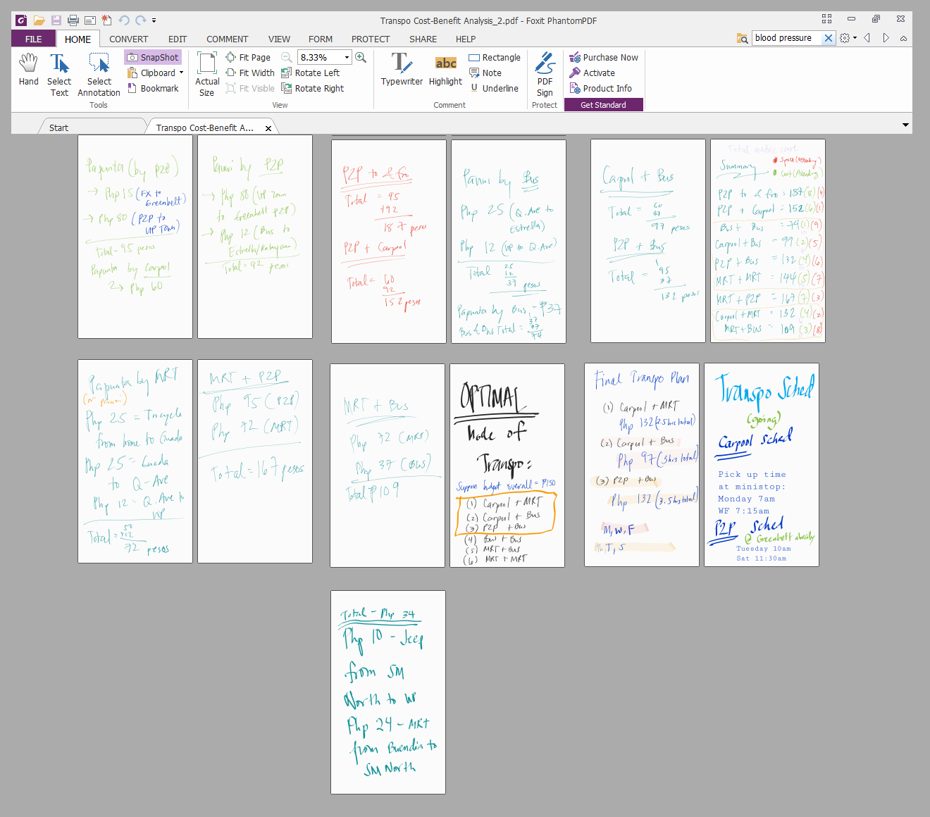

Intro 1 minute

Demo 3 minutes

Conclusion 1 minute

Working remotely is all about time management and complete autonomy

Intro ( motivation/anecdote - brief app description - target market + what its trying to solve )

What you see here is a 13-page transportation cost-benefit analysis I created before the start of the sem in preparation for my daily commute. Let me tell you the story behind this

Growing up, my little sister and I was raised by a single mom.

Before any of you go “oh no, not another sob story”

Let me paint you a picture of my mom

In her free time, my mom is a freelance gym instructor. She’s also a triathlete. In fact, her latest run was last weekend, she ran 20 kilometers, then got back home with no sweat. She’s a big fan of Bruno mars and Piolo Pascual. She’s the type who is a friend to everyone - from the guard who holds the door, to kuyang magtataho, manong magbubuko and to manang that sells tulingan. She never nags - but can stare you down like a dragon. She’s - literally the coolest human ray-of-sunshine you would ever meet.

But of course, Needless to say, being a single mother brings its own challenges.

Although She very rarely shows her vulnerability - even when she got separated from my dad, I didnt see her shed a tear

Behind the picture of my mother as this tough, all-smiles, alpha Filipina who does not fit into the picture of a typical Filipino mom at all

There’s still a side to my mom that I always thought captured the essence of being a Filipino

She always used to say “Ang mahalaga anak, magkakasama tayo”

I knew she meant it during the the very first time I ever saw her cry

Thats One of the moments that I would never forget in my life,

She was on the phone with my little sister - who was really young at the time, about 4 years old

I go to school from morning to afternoon - and my mother worked the graveyard shift from evening til dawn.

In other words, There was no one around to stay at home with my little sister - so we had to send her away to be with our relatives in Zambales.

My mom made the call to check on my sister and all of a sudden, she had to push the phone away because she was choking, she missed my sister so much - it was a really hard decision for her to send her away but we had no choice.

From that moment on, I told myself I would do anything in my power so my mom would never have a reason to cry again. Most of my blocmates are dormers but I chose the the daily commute from Makati to UP Diliman in QC - hence, this 13-page highly technical and economic cost-benefit analysis.

Liberate every filipino from the cycle corporate slavery

Everytime I ride the MRT, I remember that moment. I wonder how many of the people around me had to make a similar choice. I can feel, by the look of their eyes, that each time they ride the train, everyone around me, dies a little more each day

When I was a kid,

Thats is our motivation in creating our website

(Katipunan.com)

We want to provide employers the platform to take advantage of that filipino drive to do everything for the family - using state-of-the-art data analytics tool that records the performance rating of employees and using that rating as a basis, help employers determine who deserves to get the telecommuting privilege.

Its also a one-stop-shop from the moment you get up to the time you go home- for automated Gantt chart plotting of events and tasks in an employees life - be it work related, personal, community or for self development. Once work related tasks are assigned by the employer, the task timeline will automatically be plotted on the Gantt. The employees will also be notified of nearby community events which when they confirm to join,,would also be automatically plotted on the Gantt. The employee may also manually plot personal and family related events on the Gantt. Employees can also set their ideal priority percentage on the app - for instance, they can declare that they want to spend 60% of their time with family, 30% for work, 10% for community involvement. When the system sees an discrepancy between the user’s declared percentages and the actual schedule they plotted on the Gantt, they are notified of the imbalance; hence employees are reminded of their priorities.

Our app has work management capabilities where employer can create projects and tasks, view projects and assign tasks to employees. Depending on the status of the employees current tasks, and like levels in a game, an employee can only access a work task depending on the number of their current tasks at hand and the status of each.

Our app also includes a citizens desk where anyone can volunteer to be a responder for any type of emergency depending on their skills and the resources they have - be it health related, vehicular accidents, flood, fire and earthquakes. Volunteers are directed to training centers and when a distress call is detected, the app notifies the nearest volunteer. This helps alleviate theproblems wherr emergency response teams are stuck in traffic and rescue gets delayed. This also eliminates waitingntime in headquarters when there are no distress calls. This not only gives each citizen the opportunity to help/ to be more involved in the community but it also gives our rescuers more time with their families.

For those whom the system deems that arent cut for telecommuting, we provide a virtual queueing app to be deployed in all public tranpo terminals in the metro. It lets you notify the dispatcher of your ETA then send you a notification of how much estomated time left for your slot on the queue.

Demo

Conclusion (future plans - our business model - what more we need to deploy the tech)

We want to create a future where every Filipino won’t need to make that choice ever again

Pilipinas, Hindi lang tayo makakaraos, aasenso tayo

Brainstorm banter

Tiis tiis lang

Kaya Kinakaya Kakayanin

Lilipas din yan

Bahala na

Kaya mo yan

Push mo yan

Push mo lang, ‘te

Kapit lang

Kung gusto may paraan, kung ayaw parating merong dahilan

lupa ng araw ng luwalhati't pagsinta

aming ligaya na 'pag may may mag-aapi

ang mamatay ng dahil sa yo

The Filipino is worth dying for - not “die Filipinos, die!”

Konting tiis

Unahin ang mahalaga

Pag may tiyaga may nilaga  
Kung may hirap ay may ginhawa

Papunta ka palang, pabalik na ko

Isa-isa lang

Panindigan mo yan

Nauuna ang solusyon sa problema